Brainrot Brigade: Modular Puzzle TTRPG with optional Digital Companion

Core Concept
Tabletop roleplaying games (TTRPGs) have surged in popularity in recent years, thanks to their collaborative storytelling, improvisational freedom, and deep character customisation. From Dungeons & Dragons to sci-fi games like Mothership and a host of other streaming ‘actual plays’, young people are increasingly drawn to the mix of narrative, challenge, and creativity that TTRPGs offer.
Brainrot Brigade builds on this momentum with short, flexible puzzle-based modules - each one framed as a science-fiction “5-Room Dungeon” (a classic TTRPG format). Each room in the module is a Bebras-style puzzle challenge reframed as a TTRPG ‘encounter’. The TTRPG half of Brainrot Brigade can be played completely unplugged with a six-sided dice and paper, allowing for any code club leader or creator to become a Brainrot Brigade Game Master (GM)!
Completing each module also unlocks digital rewards that can be used in the optional companion coding projects (built in Scratch, Python, or JavaScript), which take the form of a customisable character sheet, akin to Roll20 or D&D Beyond. More features and content for the character sheet are unlocked through narrative play, via access to the project shortlinks on completion of the adventure module. These companion digital projects are non-sequential after the first, allowing for modular delivery and flexible implementation.
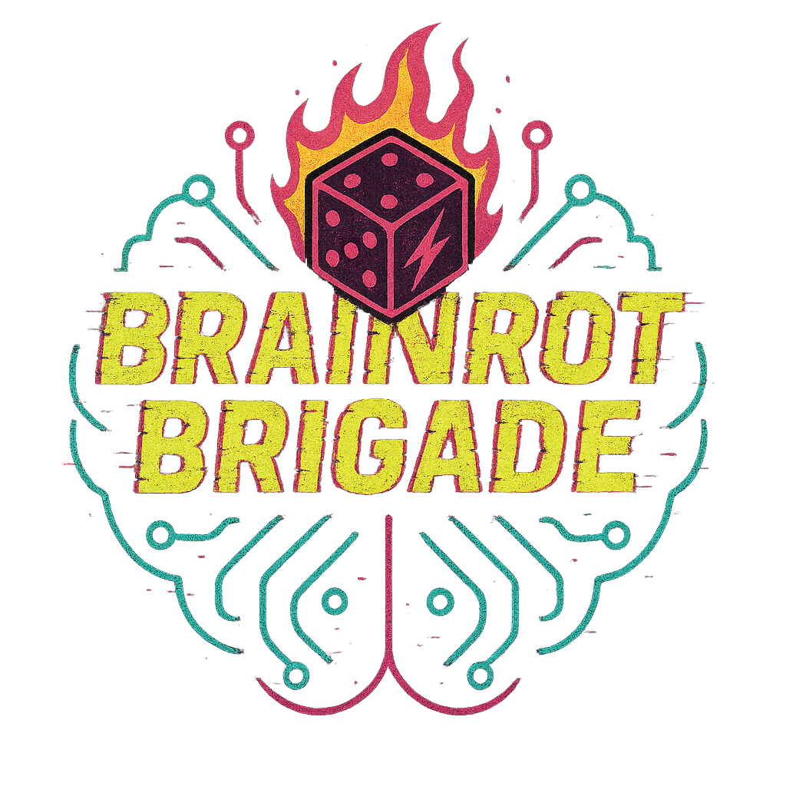
The naturally engaging Story → Unlock → Build → Play loop keeps creators returning to continue the adventure, while the gamified collection of digital ‘loot’ fuels motivation to upgrade their character sheet between sessions. This hybrid of narrative-driven puzzles and creative coding is designed to build both engagement and repeat participation over time.

Project Components

1. Adventure Modules ("5-Room Dungeons")
- Structure: Each adventure = 5 themed puzzle "encounters" (logic or instinct challenges based on ‘reskinned’ Bebras puzzles).
- Design Format:
  - Room 1: Entrance (hook)
  - Room 2: Puzzle challenge
  - Room 3: Twist or revelation
  - Room 4: Boss encounter or major decision
  - Room 5: Resolution or reward
- Delivery: Short PDF/docs with narrative prompts, puzzle challenges, and roleplay hooks. Also support notes for game masters running it with their groups.
- Optional: QR codes/shortlinks inside adventures that lead to companion project rewards (see #3).

2. Character Sheet Generator
Goal: Let players roll up random or saved characters in Scratch, Javascript or Python.
- Inputs: Randomised choices from:
  - Style (e.g. Android, Curious, Brave)
  - Role (e.g. Engineer, Hacker, Diplomat)
  - Core Number (random 2–5)
  - Name (from a fun name bank)
  - Gear (select 2–3 from a narratively-linked inventory list)
- Extra features:
  - Dice roller (d6s)
  - Prepared/Expert/Teamwork toggles in the dice roller, to simulate in-game bonuses.
  - Cloud variables inventory system/ Loot tracker
  - Avatar builder (see #4) with collectible items/costumes
  - Custom backdrops

3. Digital Loot + Expansion Items
These are rewards unlocked by completing puzzles/adventures.
- Delivered as shortlinks/QR codes embedded in the module PDFs.
- Unlock:
  - Avatar costumes
  - Narrative Inventory items (e.g. “Certificate of Safe Passage through the Zoblar System, Quantum Spanner”)
  - Custom backdrops
  - Themed digital ‘macguffins’ to be added to upgrade their Scratch/JS/Python sheet

4. Avatar System
Identikit-style character builder embedded in the character sheet project.
- Customisable layers:
  - Headgear
  - Head
  - Body
  - Legs
  - Boots
  - Accessory
  - Sidekick
- Unlockable costume parts and companions based on narrative achievements.

5. Suggested Weekly Rotation Model
Alternate weeks:
- Week A: Play through a short Brainrot Brigade adventure (solo or group).
- Week B: Implement a new feature in the character sheet project (e.g. a dice roller, new costume part, inventory function).
This creates a game loop: Story → Unlock → Build → Play again with new features.

6. Additional Ideas
- 3D printed minis of avatars as optional physical artefacts (mirrored from in-game customisation).
- All modules apart from the "Starter Adventure" can be standalone and non-sequential.
- The "Starter Adventure" includes the first version of the character sheet (basic digital tools + first custom choices).

Next Steps

Phase 1: Prototype
- Build basic character generator in Scratch (name, style, role, core number, gear).
- Add dice roller with basic logic (Prepared/Expert/Teamwork toggles).
- Draft first 5-room adventure module (include Bebras puzzles + 1 loot item shortlink).

Phase 2: First Play Loop
- Run a test coding session creating the basic character sheet & dice roller in Scratch.
- Run a test roleplay session with the starter module.
  - Players unlock their first custom loot item
- Run a test coding session where players implement a new feature into the character sheet and add their custom loot item.

Phase 3: Expansion
- Build avatar customisation UI.
- Create companion python/javascript projects with GUIZero/JS.
- Design 3–5 additional adventure modules.
- Reformat rules document and physical character sheet documents to be more digestible and authentic.
- Embed QR/shortlink system for loot across modules.

Phase 4: Digital/Physical Extras
- Develop optional 3D printable avatar parts.
- Publish modules + companion tools for wider use in TTRPG circles - DMs guild, itch.io, drivethrurpg
- Guide on creating your own adventure modules

